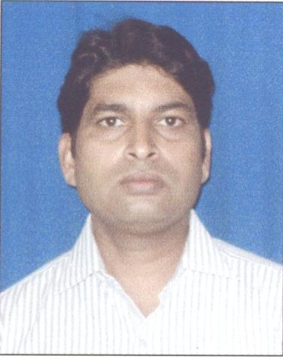 Shailendra Kumar Srivastava
+91- 8052854555
shail.silverstarinfo@gmail.com

Total Experience: 6 Years

Objective
To begin my career in a competitive and dynamic organization which provides me the opportunity to channel as well as build on my knowledge and capabilities.

Current Work Experience

Organization: INDUSIND Bank Ltd.

Designation: Assistant Manager
Period: 3rd July 2013 to till date.

Job Profile:
Deal in Business Banking (CASA)
All Types Loans, Credit Cards
Customer handling at branch office.
Team Handling
Deepening on present customers.

Previous Work Experience:

Organization: HDFC Bank.

Designation: Team Leader (Direct Sales/Liabilities-CASA)
Period: 21st Nov 2009 to 15th Jun 2013 date.

Job Profile:
Deal in Business Banking (CASA, )
All Types Loans, Credit Cards
Customer handling at branch office.
Team Handling
Deepening on present customers.

Organization: Silver Star Marketing (INDIA) Pvt Ltd.
Designation: Marketing Manager
Period: 05 Feb 2007 to 05 Nov 2009.

Job Profile: Deal in Corporate Events Organise, Sponsorship, Stalls Booking, Vender Management etc
Organization: CBMD (Centre for Bhartiya Marketing Development).
Designation: Project Manager.
Period: 20 July 2006 to 10 January 07.

Job Profile:
Deal in Theme Events (Consumers Expo, Education Expo, and Wedding Events) in different metro city (Lucknow, Agra, Kanpur, Raipur, and Nagpur)

Skills
Technical: MS Word, Excel, PowerPoint,
Classes attended: Basic operations management, Advanced operations management, Good Supervision, Time management, Change management, Empowerment, etc
Non-Technical:
- Excellent communication and customer service skills.
- Efficient organizational and time management skills.
- Detail oriented with sound analytical and problem solving skills.
Confident self-starter with strong leadership and team player qualities.

Qualification
1999 – 2001: Masters in Environmental Science, Purvanchal University
Major: Ecology

1996 – 1999: BSc, Purvanchal University
Major: BSC in Zoology & Botany.

1994 – 1996: Passed Intermediate Examination, Uttar Pradesh Board.
Govt Inter College, Ghazipur.

1994 - Passed High School Examination, Uttar Pradesh Board.
Inter College Khalispur, Ghazipur.

Extra Curricular Activities
Avid sports person, Enjoy travelling

Personal Details
Date of Birth: 30/06/1979
Gender: Male
Marital Status: Married
Address: 645 A / 65 Sector I, Jankipuram, Lucknow -226021

I hereby declare that the above written particulars are true to the best of my knowledge and belief

Reference: -

- Mr.Ajay Tiwari (Branch Head) HDFC, Lucknow. Mobile- 0935784626
- Mr Suraj Pratap Singh(BSM), Kotak Mahindra Bank, lko-9793885555

Shailendra Kumar Srivastava

